The TOMS® Story

While traveling in Argentina in 2006, TOMS Founder Blake Mycoskie witnessed the hardships faced by children growing up without shoes. Wanting to help, he created TOMS Shoes, a company that would match every pair of shoes purchased with a new pair of shoes for a child in need. One for One®.

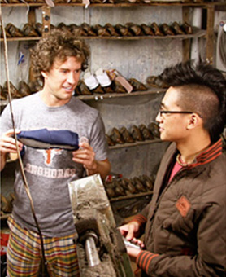
What began as a simple idea has evolved into a powerful business model that helps address need and advance health, education and economic opportunity for children and their communities around the world.

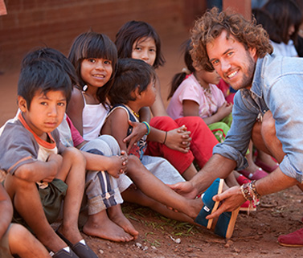

We give in over 70 countries
We've given over 60 million pairs of shoes to children in need, teaching us 60 million lessons. Since 2006, people like you have helped us achieve this amazing number – and it's leading to bigger and better things, like giving different types of shoes based on terrain and season, or creating local jobs by producing shoes in countries where we give.
TOMS® Shoes are always given to children through humanitarian organizations who incorporate shoes into their community development programs.

https://www.toms.com/about-toms

